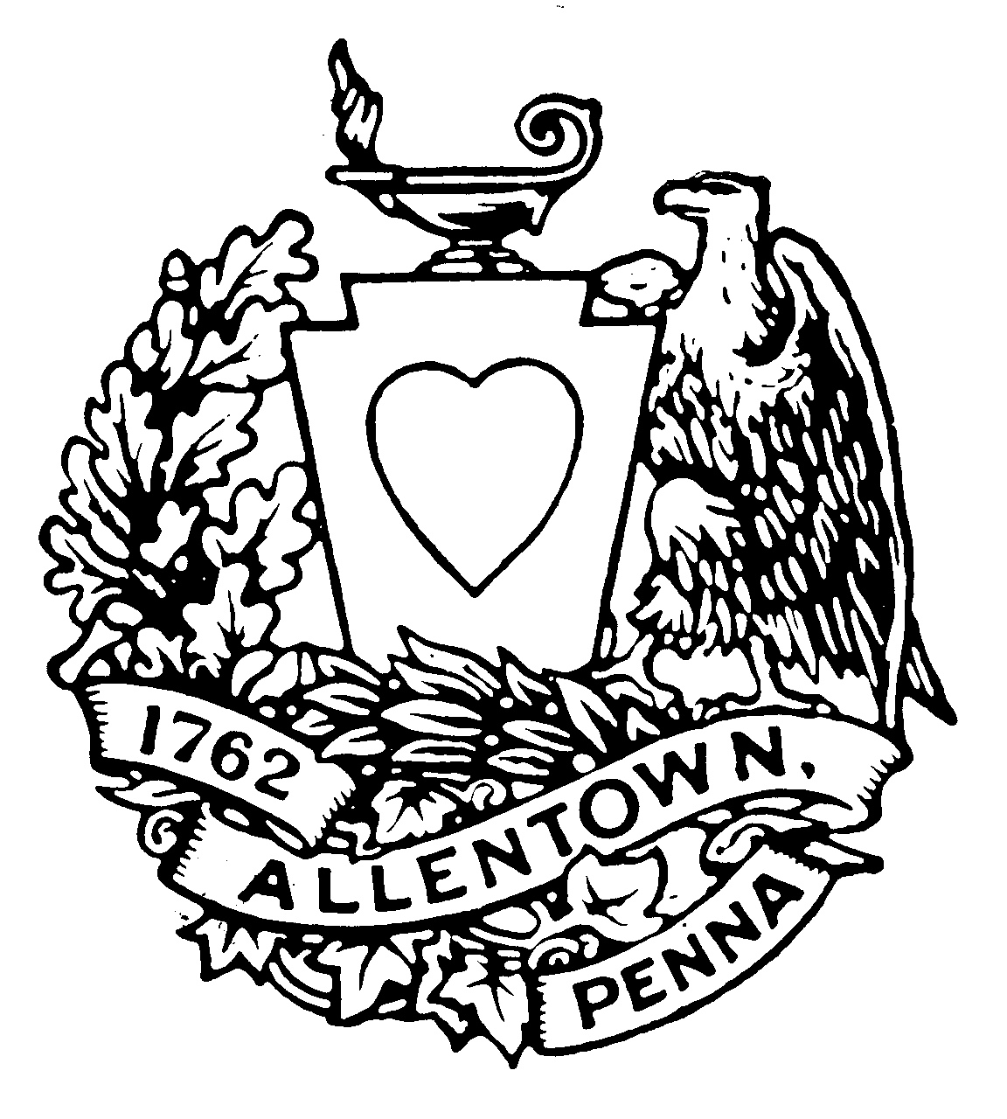

CITY OF ALLENTOWN

No. RESOLUTION R20 - 2022

Introduced by the Administration on February 2, 2022

Authorizes Acceptance by the City of Allentown for Maintenance of the Lighting System on the Tilghman Street Bridge from Pennsylvania Department of Transportation

Resolved by the Council of the City of Allentown, That the City of Allentown is desirous of entering into an agreement with the Commonwealth of Pennsylvania, Department of Transportation for the purpose of maintaining the lighting system on the Tilghman Street Bridge.

WHEREAS, the Pennsylvania Department of Transportation (PennDOT) is rehabilitating the Tilghman Street Bridge in the City of Allentown which is part of SR 1002-04B.

WHEREAS, part of this three year long project includes the installation of a new lighting system on the bridge.

WHEREAS, PennDOT, is requesting the City of Allentown assume ownership, custody and control of the maintenance of the lighting system upon completion of the project.
NOW THEREFORE BE IT RESOLVED that the Legislative Body of this Municipality enters into and agrees to the Conditions of Transfer including operation and maintenance, specifications and approval, PennDOT repairs, third party contracts, and prohibited use; all of which are defined in the attached PennDOT Agreement number 057462.

NOW, THEREFORE, BE IT FURTHER RESOLVED that the Council of the City of Allentown hereby approves of the submission to the Commonwealth of Pennsylvania, Department of Transportation, the agreement to accept responsibility for the lighting system subject to the terms and conditions in the attached PennDOT Agreement number 057462.

LEGISLATIVE TEMPLATE

- What Department or bureau is Bill originating from? Where did the initiative for the bill originate?

Public Works / Traffic Planning & Control

- Summary and Facts of the Bill

This resolution is a Roadway Lighting Agreement for the maintenance of a lighting system between the Commonwealth of Pennsylvania, acting through the PennDot and the City of Allentown.

- Purpose – Please include the following in your explanation:
  - What does the Bill do – what are the specific goals/tasks the bill seek to accomplish
  - What are the Benefits of doing this/Down-side of doing this
  - How does this Bill related to the City’s Vision/Mission/Priorities

This resolution is to enter into an Agreement with PennDot to set forth the resposibilities with respect to the Light System. The Condition of Transfer upon the completion shall include Operation and Maintenance, Specifications and Approval, PennDOT repairs, Third Party Contracts and Prohibited Use.

- Financial Impact – Please include the following in your explanation:
  - Cost (Initial and ongoing)
  - Benefits (initial and ongoing)

No financial cost to the City

- Funding Sources – Please include the following in your explanation:
  - If transferring funds, please make sure bill gives specific accounts; if appropriating funds from a grant list the agency awarding the grant.

n/a

- Priority status/Deadlines, if any

The City shall assume ownership, custody and control of the Light System.

- Why should Council unanimously support this bill?

Required by PennDot per the Agreement.

